Male Hair Transplant in Delhi

- Hair Transplants for Men
Hair Transplant is gaining popularity day by day. Among the many different hair loss treatments available, Hair Transplant is the most fruitful one. Many men are happy to accept the progressing baldness and many try to cover their baldness by wigs or headgears like hats. While some of them take support of various hair growth products such as shampoos, lotions and pills to control the hair loss. Then there are the ones who take up the surgical option of Hair Transplant where they can re-grow the hair for the rest of their lives. By Hair Transplant, men can return to their natural hairline or even develop the hairline that they desire. Even the best of Hair Restoration products can’t match up the results achieved by Hair Transplant.

Hair transplant for men is the most common type of surgical hair restoration procedure performed by Dr. Narendra Kaushik. Along with Hair Transplant on Head, Hair Transplant surgery is also performed on other parts of body as Beard, Moustache, Eyebrows and eyelashes.

- Male Hair Transplant Procedure
Hair Transplantation procedure is based on the fact that even bald men don’t lose hair from the back of their scalp and these hairs retain their property even when they are harvested in other balding regions. The healthy hairs are picked up from the lower back of the scalp and transplanted to the areas having hair loss. After Implantation, the hair follicles continue to grow permanently just like normal hair for the rest of the life without any special maintenance as they are natural hair. It takes an experienced and skillful hair transplant surgeon who can carry out this surgery without damaging the hair roots.

When a Hair Transplant is successfully carried out, the transplanted hair roots start multiplying after 2 to 3 months, giving you a natural full head young look at about 6 to 9 months.

- Dr. Narendra Kaushik’s Hair Transplant Technique
No visible signs of treatment, a natural looking hairline and right density of hairs are the key aspects of Hair Transplant surgery. Unique combination of magnified surgical techniques and expertise of Dr. Kaushik and his trained team, has contributed greatly towards achieving 100 % outcome without any side effects.

Dr. Kaushik uses Follicular Unit Transplant (FUT) and Follicular Unit Extraction (FUE) methods. In these methods of Hair Transplantation, Hair grafts ( Hair Follicle Units) are surgically dissected under magnification from the back of the scalp and harvested on the bald region. The selection of Hair Transplant Method depends upon the requirement of grafts needed in male hair transplant surgery. The area where the surgery is to be carried out is marked and based on that, possible number of grafts is picked out and transplanted.

Thanks to the concept of micro grafts, greater amount of hairs can now be harvested in a single session. One hair graft contains 1-4 hairs, so we can put as many as 4000 to 7000 hair grafts i.e. 10000-15000 hairs in a single Giga-Session. Mega-Session and Giga-Session aiming to cover maximum area with finest density, is the major distinguishing quality of OLMEC. Regardless of the method of Hair Transplant used, Dr. Narendra and his team seek minimum uneasiness and maximum results for his patients. .
- Male Hair Transplant Cost
The first question that pops in the mind before undergoing the surgery is whether or not the cost of the Hair transplant will burn a hole in the pocket. The cost of Hair transplant is calculated by the number of Hair Follicles (Grafts) required to be implanted in the areas suffering from hair loss. At Olmec Cosmetic Surgery and Hair Transplant Centre, the cost of Hair Transplant is reasonable and there are no other hidden costs. To calculate the Number of grafts required, click here.
- Causes of Hair Loss in Men
Little is known about the exact cause of Hair Loss but it may include several factors and it varies from person to person. Some of the symptoms of Hair Loss are:
- Gradual thinning of hair
- Appearance of bald patches
- Change in hair growth pattern
- A Family History of Hair loss

The most common form of hair loss is Male pattern baldness caused by the male hormone DHT (Dihydrotestosterone). A few of the other common causes are Inflammatory scalp, Disorders of hair growth, Telogen effluvium, Anagen effluvium, Alopecia Areata, Traction alopecia, Trichotillomania , Parasitic Infection, Drug induced Hair loss and False cosmetic procedures. Depending upon the degree of advancement, some of these scalp conditions can be treated with medicine itself while others allow for surgical treatment. By fully understanding the evolution of male pattern hair loss, Dr.Kaushik is able to create hair restoration results in men through Hair Transplant which is the permanent solution providing dramatic effects.
- Recovery Following Male Hair Transplants
Hair restoration is a day-care procedure and the recovery is immediate. Generally, one can easily continue their routine the following day of the surgery. One can wear a hat or cap immediately after surgery if they wish to cover any scabs. Regular hair wash can be done with care the next day. The recently transplanted hair is visible even on the day of the surgery. The hair starts growing in a progressive manner and one can notice the change month after month. It is suggested to avoid any demanding activities for a week to prevent any unexpected injury.
- Hair Transplant Results In Men
The Hair Transplant results are everlasting; it looks natural and is free from any special maintenance. The post-transplant hair yields 100% results and grows for the rest of your life. It needs cutting, can be washed, combed, oiled and styled normally; giving pleasing results. Other procedures, such as hair weaving, bonding, coloring are only artificial and temporary; which often result in damaging your existing hair.
- Male Hair Transplant Before and After Photos
One can easily understand about the results gained from a male hair transplant by comparing the before and after photos. Though each case is different for every individual, the before and after photos bear examples to the ways the issues of hair loss are dealt with, by Hair Restoration surgery. We have included one before and after photo of a male hair transplant performed by Dr. Narendra Kaushik below, but to view additional photos, view our Hair Transplant photo gallery.
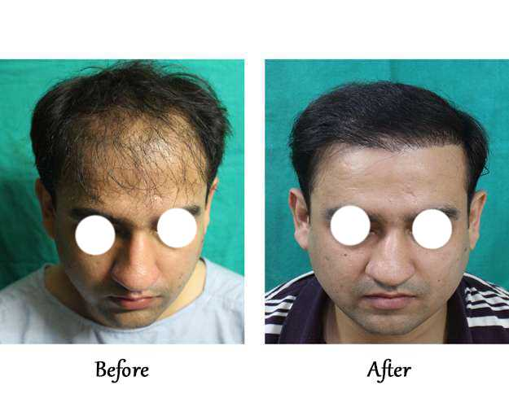
Age: 28 Grafts: 4800

- About Male Hair Transplant Surgeon Dr. Narendra Kaushik
Dr. Narendra Kaushik is one of the leading Plastic, Cosmetic and Hair Transplant surgeons practicing since 14 years in New Delhi, India. He has received Awards and Certification from many Institutions for his expertise in Cosmetic and Plastic Surgery. He is an active member of Association of Plastic Surgeons of India (APSI) and Indian Association of Aesthetic Plastic Surgeons (IAAPS). He has founded ‘Olmec Cosmetic Surgery and Hair Transplant Centre’ along with a team of professionals. With state of the art amenities and skilled team, Olmec has acquired its reputation in India as well as abroad.
- Schedule your Hair Transplant Consultation
For more information on hair transplant surgery for men, or to schedule your consultation with Dr. Narendra Kaushik call our office at + 91 11 45028004 or email us at info@hairtransplantdelhi.com and we will get back to you to fix an appointment. During your hair transplant consultation, Dr. Narendra Kaushik will analyze and discuss the options, benefits and limitations of hair restoration surgery with you. Also, you will receive detailed information about costs and recovery process. At Olmec, we target to assist you for making the most informed decision possible about whether or not the Hair transplantation surgery is your perfect choice for curbing hair loss and helping you to obtain aspired results.

